My Microsoft Selection Process Experience

Microsoft was the first company I was shortlisted and reached the interview round clearing the first level test. The experience was rewarding in many sense. This is my first interview experience and I am thankful to all my batch-mates and seniors whose valuable suggestions helped me in emerging successful in this interview. Here I present my experience.

Round 1 (Written Test): S-301
There were 3 questions. In all of them we were asked to write the code. The problems are as follows.

1. The input is a binary search tree (BST) and an integer N. We define a node in the BST whose value is less than N and closest to N as predecessor of N. Find the predecessor of N in the BST if it exists by writing a C-code. Return the pointer to the node which is predecessor to N if it exists, or return NULL if it doesn’t exist. The code should not contain any global or static data. (i.e. re-entrant data).

struct node{
int val;
struct node* left;
struct node* right;
};

node* findPredecessor(node*root, int N);

2. Find whether a singly-linked list (L2) is sublist of another singly-linked list (L1). If the L2 is indeed sublist of L1, then return the pointer pointing to the 1st element of the sublist in L1.
e.g.
L1 = 10→20→50;
L2 = 10→50;
Return the pointer to the value 10 of L1.

3. Let E be a set such that it contains 1. Also there is another input N. Generate all the values less than N, using the generator function: 2x+5y where (x==y) is allowed.

Round 2 (Group Activity): S-301
After this round, 27 (From 112) were shortlisted. This second round was called “Group Activity”. The idea in this round was to solve problems in consultation with the Microsoft recruiters. Think of some idea and discuss it with the person allotted to u and then code the algorithm. This was the rule of the game. So people who preferred to solve the problems individually got thrown out in this round. In this round the following problems were thrown to us.

1. There are 3 (non-decreasing) sorted arrays, namely A, B and C. Define a triplet (a, b, c) such that a is in A, b is in B and c is in C. Also, define
dist (a, b, c) = max (|a-b|, |b-c|, |c-a|)
Now find the triplet (a_min, b_min, c_min) from A, B and C such that dist (a_min, b_min, c_min) is minimum among all possible triplets.
Hint: Brute force method: Compute all possible triplets and return the triplet with the min dist value. Smarter Approach: Use 3 pointers. Allot single pointer for single array. Initialize each one of them with the first positions of each of the array. Now compute the dist of the triplet formed by the values pointed by the pointers. Update the bestTriplet if the cost is less than bestTriplet. Next increment the pointer which points to the minimum value among the three. The philosophy is similar to the merge-sort. Only difference is that, actual merging is avoided since merged array does not guarantee three consecutive elements to be from three different arrays A, B and C. The proposed algorithm takes O(n(A)+n(B)+n(C)).

2. There is a circular array which is a queue (FIFO). Several threads are trying to either insert or delete elements from the queue. Write code for insert, delete, IsFull, IsEmpty such that the functions are synchronized enabling parallel insertion and deletion.
Hint: It is simple. This problem requires smart use of semaphores.

Round 3 (Tech Interview): SAM Hall
In this round I met a guy who was the most geeky kind of person. He didn’t even smile at PJs probably. His first question was to describe my project in summer training. The guy had no knowledge in VLSI and related stuffs. So I started the first class lecture of my CAD for VLSI course by Prof. PPC. I described him the basic steps of VLSI design starting from the High-level design to the fabrication. He had many doubts and it seemed that he was impressed with my explanations.

The next question was as follows:
Consider the skyline of a city shown in the picture below. You are given with the (x_{i}, h_{i}, w_{i}) for n buildings. You have to give the silhouette of the city.

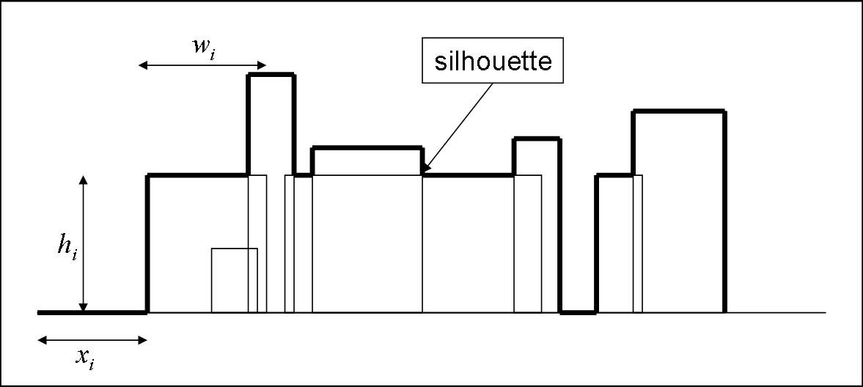

I proposed one O(n²) algorithm by proposing a construction a graph where each building represents a vertex and there is an edge between two vertices if they are overlapping. For example i^{th} and j^{th} building has an edge between them then either,
x_{i} <= x_{j} <= x_{i} + w_{i} or x_{j} <= x_{i} <= x_{j} + w_{j}
However, he suggested me to optimize the data-structures. Then finally stored the data in a heap and seemed that he was happy. Lastly he said, “I was not interested in the answer actually. It was nice talking to you.”

Round 4 (Tech Interview):
In this round, I met a bashful person who asked me the following.
1. Code the move of a game which was pretty simple in nature. I am not describing it here. But the tips (courtesy: Chandu and Dhawan who generously contributed towards the Q&A library building during the placement of 2006 batch) that I applied here was, a) code to the detail, b) check the boundary condition c) explain each line to the recruiter, d) ask the recruiter whenever u have any doubt or before making any assumptions and e) definitely think aloud.

2. There is an array where except one number (say magic-number) all are unique. The magic-number repeats itself more than half times the size of the array. e.g. 2, 10, 10, 10, 3. Find the magic-number without using any extra-space and without sorting it.
Hint: Use the given property, “magic-number repeats itself more than half times the size of the array”. This ensures (from Pigeon Hole Principle), that there exists at least one triplet (triplet here stands for 3 consecutive elements in the array) which has the magic-number more than once. So scan the array once and search for the magic-number.

3. Gave a simple ‘strcat’ code and asked for the errors in it. The errors were the following:
a) there was no ‘\0’ in the end.
b) returning a pointer to a character array which is locally declared in the function.
He asked me to correct the code. Simple task.

4. Asked the difference between C++ and Java.

Round 5 (Tech-HR interview):
In this round the head (Shankar Shastry, the man who came in the PPT) of the recruiting team called me. He was a nice guy. He asked me about the project in my summer training. Again I lectured him about LISA, ADL, RTL, VLSI design, automatic test pattern generator etc. Then he asked me how do the methods on semaphores are implemented. I didn’t remember anything of that part in OS. I gave a long funda on hardware bit setting, interrupt handling, atomic execution, preemption of the processes etc. I knew that I was not very sure of what I was talking to him, still I continued. Then he asked me about the favorite subject of mine. Also, he asked me to name a product which fascinates me and why? Moreover, what kind of product would I like to work upon. Last question made me apparent of the selection. He asked “Is
there any question for me?”

So this was my experience in Microsoft interview. I liked the problems they asked me. The suggestions for an aspirant would be following.

1. Come prepared with fundamental data-structures and algorithms.
2. Industry people find the “code” nearer to their heart but feel uncomfortable with “graphs”. They are real expert in the code, but theoretical abstractions are grey areas for them. This is my own realization and I may be absolutely wrong.
3. Interact, interact and interact with the recruiters during the interview. Think aloud. It helps. They are not interested in getting a correct solution but they are more interested in the effort u r putting in and moreover the line of thought that you are having. Above all, remain confident even if u do not know anything about the answer.
4. The interview might span over 7-8 hours at a stretch. So keep biscuits with you since in empty stomach u cannot think smart. I did not do it, but Sankalp Agrawal (my dept-junior and our dept-representative) bought me a packet of potato chips and kurkure. Thanks Sankalp!

All the Best!!!

Arnab Sinha, Dual Degree, CSE
(Campus Placement – 2006-2007)
Email: arnabsinha@gmail.com

